Zoom Web Meeting Integration & OAuth App Creation Instruction Guide
1. Build app in Zoom Marketplace for your portal: https://marketplace.zoom.us/
2. Create OAuth app
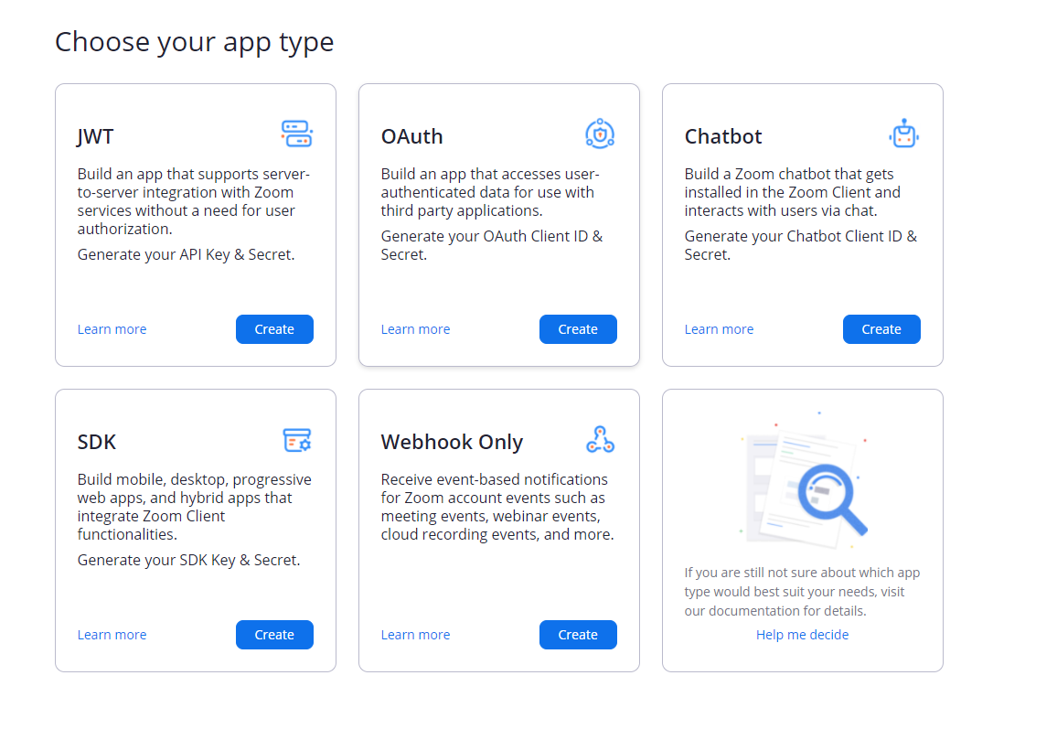
3. Name the App
4. Set app to “User-managed app”
5. Click create
6. Copy the “Redirect URI” from the Zoom tab in the web meeting integration page of Inquisiq for this portal
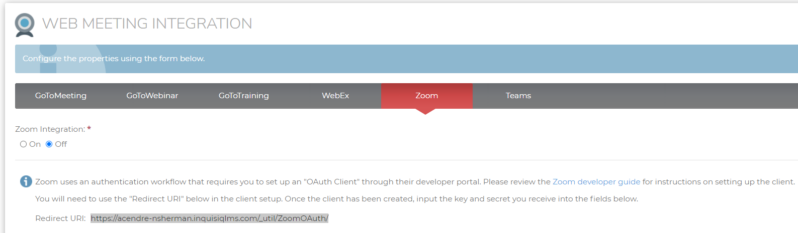
7. Paste this URL in the Zoom app setup page under “redirect URL for OAuth” & “add allow lists”
8. Click on “Scopes” tab on the left-hand side
9. Turn on all scopes for all categories
10. Copy the client ID and client secret codes from the Zoom app and paste them into the web meeting integration details in Inquisiq for this particular portal
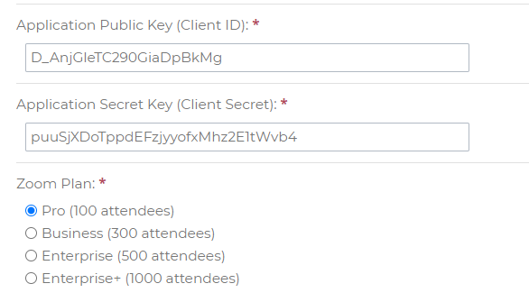
11. Save changes at the bottom of the Inquisiq page
12. Create an ILT Session with your newly integrated Zoom account

