Setup Instructions for Zoom App & Web Meeting Integration in the Portal:
- Open a new internet window / tab and login to the Zoom Marketplace

- Build an OAuth app from scratch in the Zoom Marketplace:
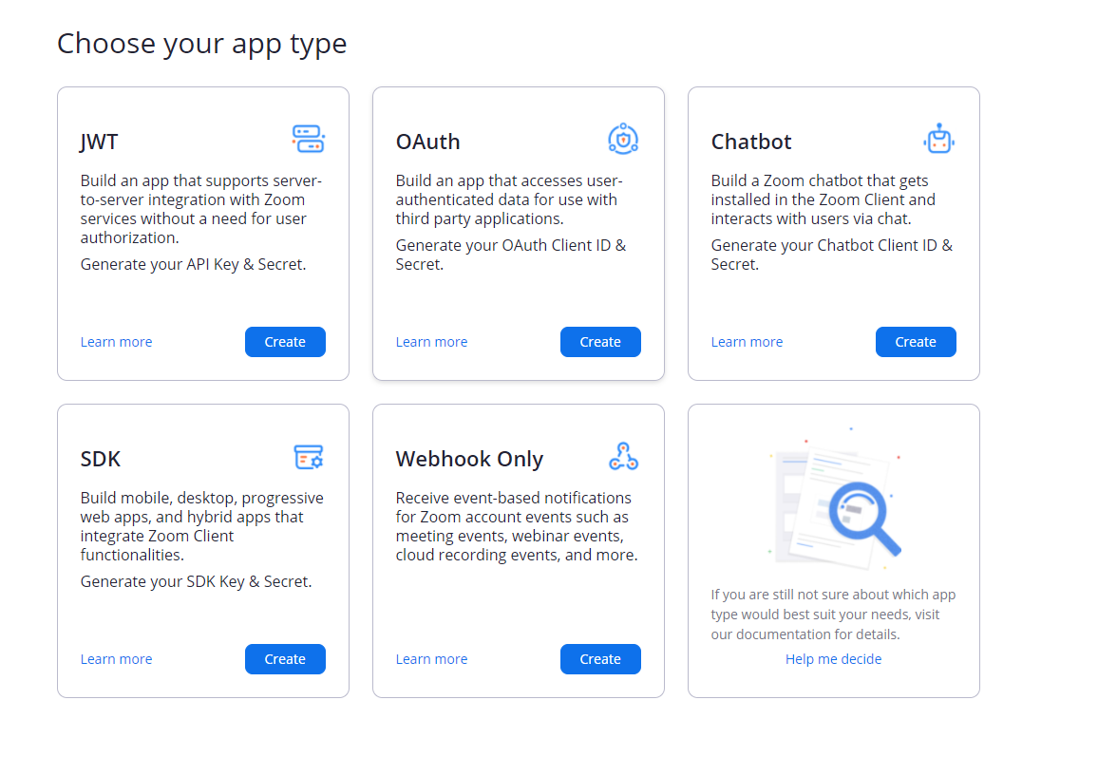
- Name the App.

- Set app to “Account-Level App.”

- Toggle off the publishing settings at the bottom of the window.

- Click create.

- Paste “Redirect URI” URL into the Zoom app setup page under “redirect URL for OAuth” & “add allow lists.”

- Click on the “Scopes” tab on the left-hand side. Turn on all scopes for categories Meeting through Account. Turn on all available scopes in these categories.

- Copy the client ID and client secret codes from the Zoom app and paste them into the web meeting integration details in Inquisiq for this portal:
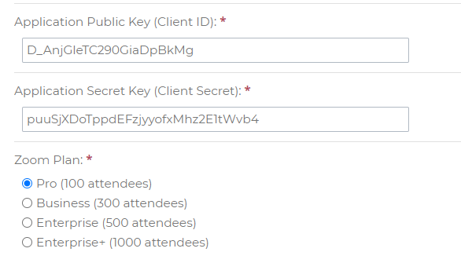
- Save changes at the bottom of the Inquisiq page

- Create an ILT session and login with Zoom

